Bdecan report for March 2020 Presbytery Meeting

Kids Winter Wear Giveaway 2019

A huge thank you to everyone who helped provide, sort, and give out winter clothing at our giveaway November 26th. We gave out winter wear items to about 68 boys and 50 Girls.

It is because of your donations that we can continue to do this event year after year. You have no idea how important this event is to our community.

Many families would not be able to get their kids the winter items they need without this event. Thank you so much!



**Bdecan VBS 2020**

Our Friends from First Presbyterian Church in Rochester (and other Presbyterian churches) will be back for a 6th summer July 6th – 12th.  
It is a week of Bible stories, music, games, great food, and tons of fun. The kids at Bdecan look forward to VBS all year long.

We love it when this group comes each summer.  
We are very excited for their return!

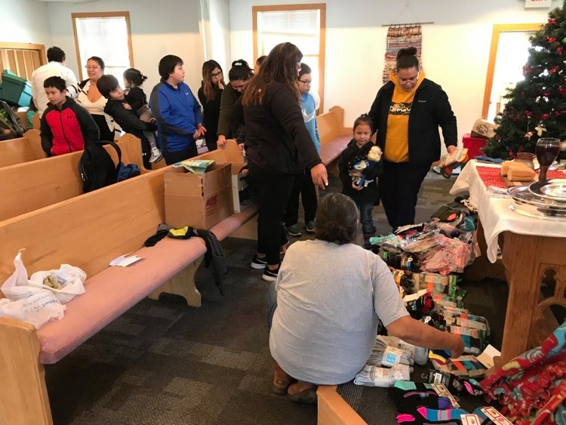

Christmas Service December 22  
We had a huge day in worship on Sunday, December 22nd. We had our kids tell the Christmas story and share special music. We celebrated Communion together and baptized 5 children into the church.  
Following worship that day, the church members gave out the gifts from the Bdecan Ministry Team to all the kids and youth presents. Following the gifts, there was a huge potluck put on by the church members.

A huge thank you to all who donated towards our Christmas gifts to the kids this year. Your gifts were appreciated.

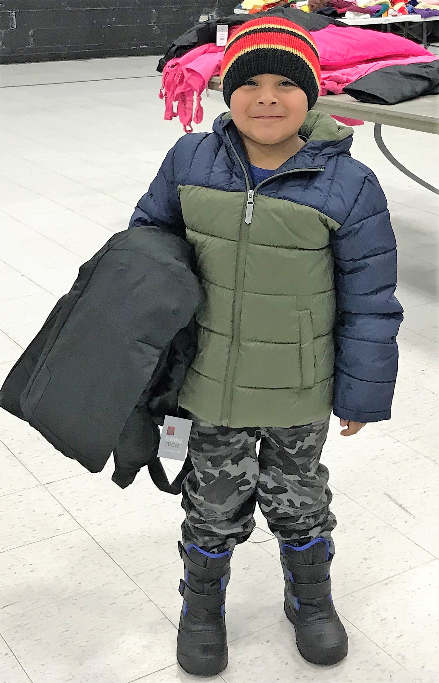 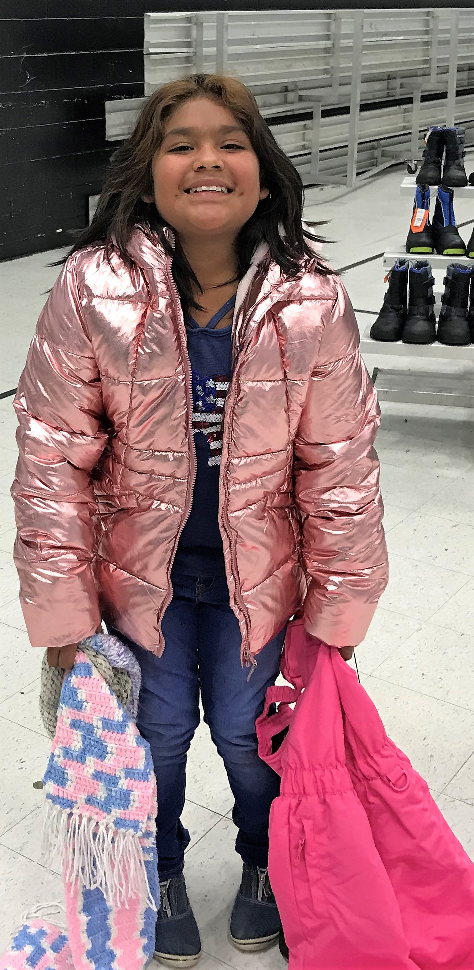

Food Pantry stats September 2019 – February 2020

September 2019 Food Pantry

|  |  |
| --- | --- |
| **Households ND** | 37 |
| **Pounds ND** | 917 |

October 2019 Food Pantry

|  |  |
| --- | --- |
| **Households ND** | 71 |
| **Pounds ND** | 1734 |

November 2019 Food Pantry

|  |  |
| --- | --- |
| **Households ND** | 57 |
| **Pounds ND** | 1170 |

December 2019 Food Pantry

|  |  |
| --- | --- |
| **Households ND** | 49 |
| **Pounds ND** | 1171 |

January 2020 Food Pantry

|  |  |
| --- | --- |
| **Households ND** | 45 |
| **Pounds ND** | 960 |

February 2020 Food Pantry

|  |  |
| --- | --- |
| **Households ND** | 36 |
| **Pounds ND** | 719 |

**Submitted by Joe Obermeyer  
Youth and Outreach Coordinator  
Bdecan Presbyterian Church**