Presbytery of the Northern Plains
5555 South Washington Street ~ Grand Forks, North Dakota 58201
(701) 772-0783 or (800) 243-3532 Fax (701) 775-7599
www.northernplainspresbytery.com

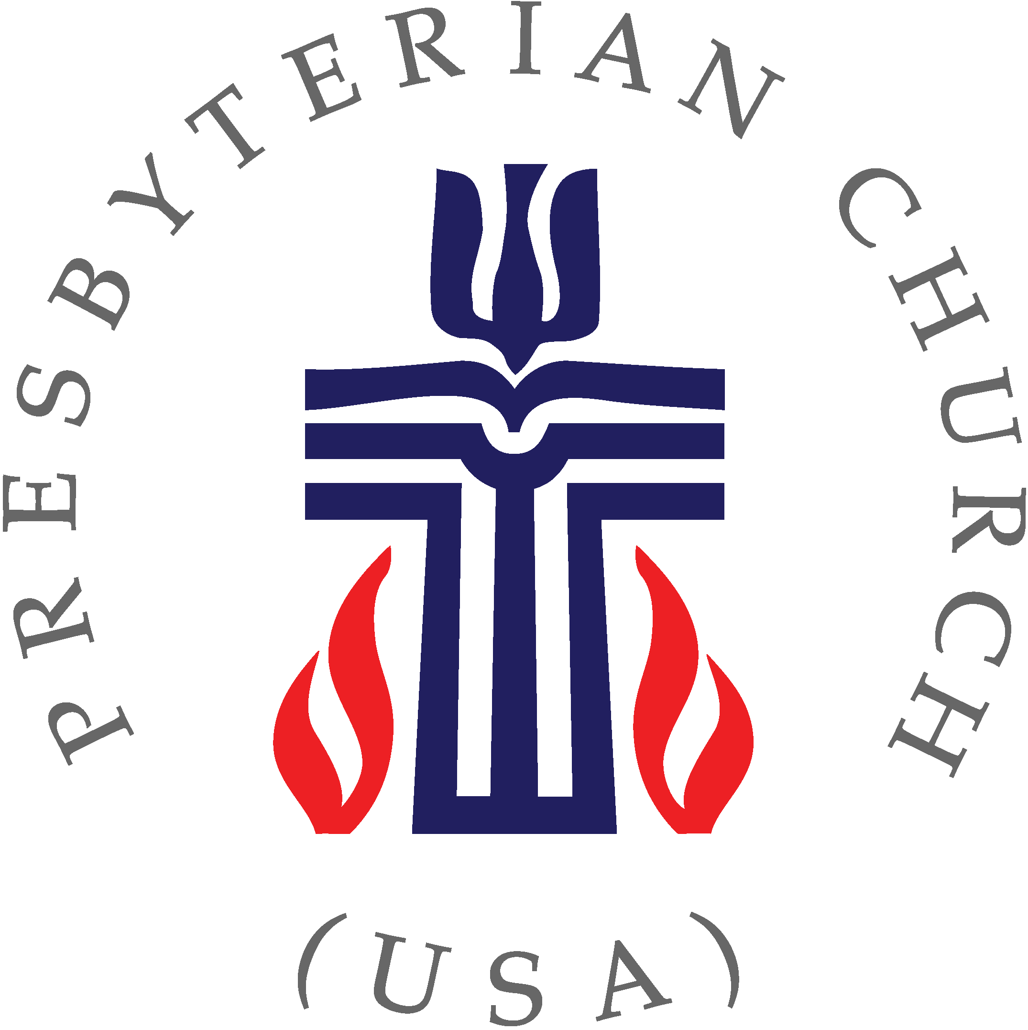

Moderator
Donna Monteith
701-866-3882 (cell)
grpresby1@midconetwork.com

Vice Moderator
Sylvia Pringle
mamachips2@gmail.com

Presbytery Leader
Marjorie Ackerman
701-772-0783
revmarji19@gmail.com

Stated Clerk
Michael Lochow
701-200-6794 (cell)
sc.pbynp@gmail.com

Treasurer
Sherri Stern
701-429-3522 (cell)
John.sherri.stern@gmail.com

CALL FOR THE MARCH 2020
PRESBYTERY MEETING

The One Hundred Twenty-Second Stated Meeting of the Presbytery of the Northern Plains will be held via Zoom video conferencing, on Saturday, March 28, 2020, beginning at 10:00 a.m.

As you know, the face-to-face meeting of the Presbytery of the Northern Plains originally scheduled to be held at the Baker-Downer Westminster Presbyterian Church has been cancelled because of the health crisis. However, there were several items on the agenda for that meeting that require timely attention and cannot be postponed. To attend to these items we have scheduled a meeting via Zoom call. The link for the Zoom call is https://zoom.us/j/641501852 The link will open at 9:00 a.m. to allow commissioners wishing to attend to get their computers setup.

The agenda for the meeting has been revised to include only those items of business that require our immediate attention. There are four items of business on the agenda.

- The examination of Jamie Norstag as a CLP and commissioning him to the Midway Parish churches (Gilby, Forest River, and Inkster)
- The consideration of the approval of the granting of an easement to the Minnesota DNR by the Presbyterian Clearwater Forest*
- The appointment of a Closing Commission for the Emerado church
- A report from the Committee on Nominations nominating a new vacancy counselor for the Presbytery
*Five entities own the Presbyterian Clearwater Forest. They are the Synod of the Lakes and Prairies, Northern Plains Presbytery, Northern Waters Presbytery, Southwest Minnesota Presbytery, and the Twin Cities Area Presbytery. The granting of this easement requires the approval of all five entities. The easement will be on 146.44 acres of land in return for a payment of $ 1,663,620. The Board of Directors of the Presbyterian Clearwater Forest has voted to recommend approval of the easement. A copy of the agreement and an accompanying power point are posted on the Presbytery’s webpage.

Presbytery meeting materials will be posted and available on the Presbytery website at www.northernplainspresbytery.com to download. If you have any questions or concerns, please feel free to contact the Presbytery office at 701-772- 0783, the Stated Clerk, or either by email.

