Presbyterian Commission on Closing the Church at Emerado
Zoom Meeting Minutes
May 21, 2020; 3:15 PM

Members present: Robin Dill, pastor at Grafton and Minto; Darrel Cory, pastor at Thief River Falls; Elizabeth Swee, elder from Moorhead; Sally Jacobsen, Clerk of session at Emerado; Patty Purath, elder at Red Lake Falls
The meeting was opened with prayer by Sally who volunteered to be the chairperson of this commission.
Patty volunteered to take notes.
Sally read the plan that had been approved by the session and congregation of the Emerado Church to transfer ownership of the church building to the Emerado Volunteer Fire Department (EVFD). The church building, built in 1928, would be a museum, and also a food shelf in the lower level. The plan included committees to oversee the museum and food shelf for futurity.
Darrell Cory made the motion- Barring any concerns from the stated clerk of Presbytery the Presbyterian Closing Commission agrees and recommends the plan, seconded by Robin Dill and motion carried.
Sally will send the plan to the stated clerk and report back to the commission.
Sally also provided plans about the pews and religious items in the church. Religious items and furniture in the Sanctuary will be featured in the museum. The pews will be made available to purchase by church members. Besides the pews other nonreligious and non-historic items will be on sale on August 15th. On August 16th, there will be a celebratory service with a meal served.
Church monies will be used to pay bills and also for food for the celebration. The process of closing and disposing of items in the church needs to be completed by Dec. 13th, when the insurance expires.
The next step for this commission is to wait for information from the stated clerk. Darrel Cory reported that this commission will also arrange a final worship service to be held by the Presbytery.
Robin Dill made a motion to adjourn, seconded by Darrel Cory, and meeting was adjourned.
Sally Jacobson closed with prayer.

Minutes of the Presbytery Closing Commission zoom meeting—July 2, 2020; 3:30 p.m.
Commission members present—Sally Jacobson, Robin Dill, Elizabeth Swee, Darrel Cory, Patty Purath
The meeting was opened with prayer by Darrel Cory.
Sally reported that the church basement was flooded following the 10 inches of rain that had fallen the previous night. She will be doing more work after the meeting to see how extensive the damage is. The church was hoping to have their worship service in November with the final service then, but with the damage to the church and covid-19 concerns the final service will need to be changed.
Darrel Cory made a motion to set the date on August 16, 2020 at 11:00 AM. The motion was seconded by Elizabeth Swee and carried. This corresponds to the sale of church items to take place on August 15th.
Sally asked about letters of transfer for members going to other churches. Darrel explained that Presbytery will assist with that. Most communication is now virtual and the administrative commission of presbytery contacts the church where you want to move. Next time this commission meets those transfers can be approved.
Sally volunteered to notify Donna Monteith, moderator of Presbytery, and invite her to the final service. A simple lunch will be served with masks required and social distancing observed. The worship service format was discussed. The final service would follow the regular order of worship with regular worship music.
Blue Hymnals and Bibles will be disposed of. There can be a sign-up sheet for the Bibles. Jamie could help with advertising for the dispersion of the hymnals. We must provide for the care of church records and deliver to Presbytery to be archived.
The meeting was closed with prayer.
Robin made a motion to adjourn, seconded by Patty.
Secretary, Patty Purath

CLOSING COMMISSION EMERADO PRESBYTERIAN CHURCH
ZOOM MEETING – 3:30 P.M.; JULY 16, 2020

I'm sorry it has taken me so long to get these minutes out. It has been a very busy time what with the flood water, drying out everything, planning our closing and disposition of the non-religious/historic items.

I am very pleased with the disposing of the dishes, cookware, glassware, cups, etc. I happened to be in conversation with a person from Community Action and asked if they would have any use for any of these things. They said they are in partnership with a ND Vet's program and can use everything that we don't need. So - they are coming out, packing it, and distributing it.

I'm going a little crazy arranging social distancing seating, but working on it.

Darrel said that he won't be able to make it to our August 16th closing. Robin said that it would only be him coming. How about Elizabeth and Pat? Do you plan on coming, if so, how many?

Donna Monteith also sent some closing info.

Do we need another zoom meeting???

Please let me know and if the minutes are ok as I printed them.

Thanks for everything!

Sally Jacobson, Chair

Revised proposal

Proposed Plan for Presbyterian Agreement for ownership and operation of 208 Main Street (Emerado Presbyterian Church)

The Emerado Presbyterian Church has been a foundational piece of the Emerado community for more than 140 years. Recently, the church has made the difficult decision to cease offering congregation services and wishes to relieve the church of the physical property and building. The church’s long history in the community has left its mark on time and Emerado, and for this reason, the congregation wishes that the property and building continue to serve the community.

This document proposes to transfer ownership of the church building to the Emerado Volunteer Fire Department (EVFD) to be governed by the volunteer board of directors (of EVFD) through a committee structure. The primary reason for this ownership structure is because the EVFD is a permanent fixture in our community and the intention of the church is to donate the building and property to permanently serve the community.
The intent of this committee is to establish an Emerado Museum on the upper level of the building and a food shelf to operate out of the lower level. The museum will exhibit the rich history of the Emerado area as an agricultural community and a long-time home to Grand Forks Air Force Base. The food shelf will provide a necessary service for our community since the closest food shelfs are in Larimore and Grand Forks.

To carry out this work, this document proposes that the city form a Museum committee. This will be a committee of the EVFD and will operate as a public group including, publicly noticing all meetings and ensuring all meetings are open to the public. The committee would operate in perpetuity.

Proposed membership of the committee consists of 5 members, including:
- 1 member of the Emerado Volunteer Fire Department
- 1 member of the Emerado City Council
- 1 member of the Emerado Park board
- 1 member of the Emerado Community Development Coalition
- 1 At-Large member

If the EVFD of Emerado adopts the approach articulated in this document, then they agree to operation of the building and accept financial liability of both the building and property, including expense of operation and maintenance. It is also acknowledged that the EVFD is committed to and agrees to support the mission to operate the museum and food shelf in perpetuity. The EVFD will not change the mission of the building, property, or committee (to the best of their ability). With that being noted, the EVFD does, ultimately, reserve the right to make any final decisions concerning the property, its use, and upkeep or maintenance, although it is expected any decision would be made in consultation with the Museum Committee.

The Museum committee will oversee operation and programming of the museum and food shelf. They will prioritize sustainability of operations by seeking grants and other revenue streams to ensure the museum and food shelf operate in perpetuity.

Community Interests
E-PAPER

Presbyterian Church in Emerado, N.D., will close, but will reopen, later, with a new purpose
Written By: Ann Bailey | Aug 15th 2020 - 7am.
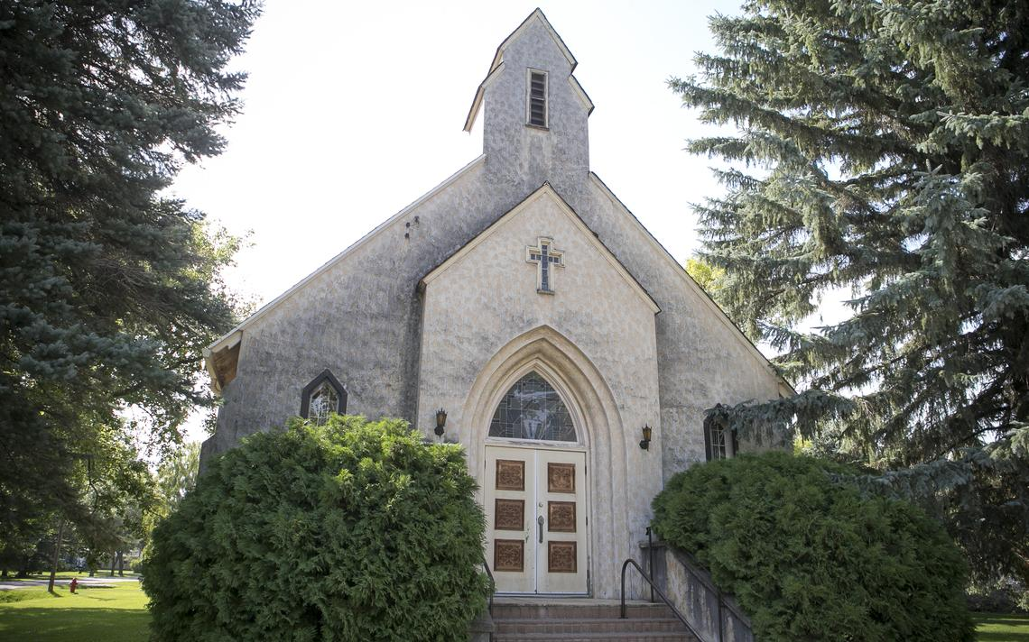
The Emerado Presbyterian church will hold its final service Sunday. Photo by Eric Hylden/Grand Forks Herald
EMERADO, N.D. – On Sunday, Dec. 2, 1928, the Emerado Presbyterian Church congregation gathered for the dedication of a new worship space. Ninety-two years and about 4,700 Sundays later, on Aug. 16, 2020, the congregation will worship together for the last time.
A dwindling rural population, an aging congregation and a decline in the number of young people who attend services has resulted in financial hardship for the church, said Sally Jacobson, a longtime member. As a result, church members voted to close it.
While Emerado Presbyterian Church members say they will be sad during the desanctification service Sunday, they are comforted knowing that the church will not fall into disrepair. The church sanctuary will be used as a museum and the basement will house a food pantry. The Emerado Community Development Commission will own the museum, and the Emerado Volunteer Fire Department will run the food pantry, in cooperation with a food bank.
The food pantry will be important to the community, whose members needing food and other personal care now have to travel to other towns to obtain it.
Meanwhile, the Emerado museum will showcase the history of the town and preserve the history of the church.
Closing the church, built by the late Joseph Bell DeRemer and his son, Samuel Teel DeRemer, was a difficult decision for the remaining dozen or so congregation members, some of whom have ancestors who were present for the dedication ceremony. The church has a long history in the community, beginning in 1880 when services were held in a claim shanty six miles west of Emerado. In 1887, a church was built in Emerado and worshipers attended services there until the building burned in May 1928. By December of that same year, they were in a newly constructed church.
In the early days of the church, as many as 125 people attended Sunday services, Jacobson said. And as recently as 1981, about 90 parishioners were members.
Nicole Martin, at age 46 one of the youngest adult members of Emerado Presbyterian Church, recalls that during the 1980s, the church held Sunday School classes and vacation Bible School. Confirmations and baptisms still were fairly frequent.
That has changed during the last two decades, with the last confirmation at the church held 13 years ago, and the last baptism about six years ago.
The decline in church membership at Emerado Presbyterian is not unique, said the Rev. Raenelle Sorensen, pastor of the Yoke Parish of Emerado Presbyterian, Arvilla (N.D.) Presbyterian and Larimore (N.D.) Methodist.
“There are an awful lot of churches and very few people,” Sorenson. “It used to kind of be an outing. The church was full."
Sunday morning worship has been replaced by sports and other children’s activities, she said.
“Our communities are fragmented,” Sorenson said. Besides having other obligations on Sundays, parents sometimes use the day to decompress, instead of attending church services, because they are tired from working all week and driving their children to various commitments.
“I think many kids are missing out on any kind of ability to grow their faith because it’s not a priority for many families,” Sorenson said.
But for the church’s loyal members, such as Martin, the other members have become family.
“This was always our home. Even when we lived in Denver, this was our home church,” said Martin, who moved back to Emerado and now attends services at the church with her two children, Grace and Hayden.
Feryl McEwen has been a member of the church for 49 years, joining when she, her husband and three children moved to a farm west of Emerado.
“They came in '71, so they’re ‘newbies,’” Jacobson said with a laugh. Jacobson, 75, has belonged to Emerado Presbyterian her entire life, continuing to attend services and play the organ long after she and her husband moved to Grand Forks.
“We’re family with people here,” Jacobson. “I was baptized here. I was married here. Our kids were married here, baptized here."
She and other members are pleased, though. After the final worship service, people still will have an opportunity to climb up and down the steps and enter a well-maintained building at 208 Main Street in Emerado.
“There’s so much history, I thought it would be good to preserve it. We can keep our religious and historic items here, and when people come back, they can see the things,” Jacobson said. “I’m glad we have a plan. We’re grateful for that.”
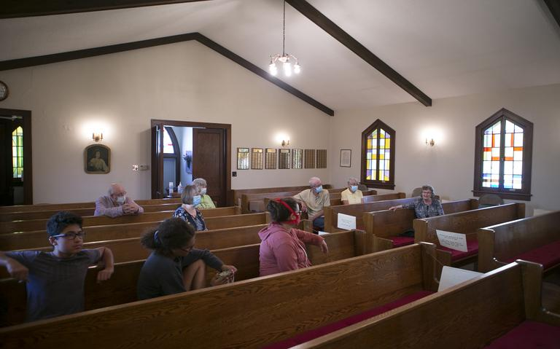
1 / 2
Members of the Emerado Presbyterian Church share memories of the historic church recently. Photo by Eric Hylden/Grand Forks Herald

