Clearwater Forest Camp & Retreat Center
October 2019
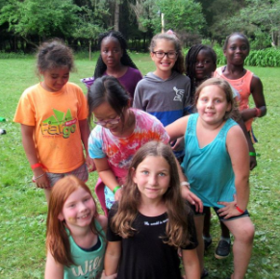
Our Mission - Clearwater Forest is a ministry of Christ called to provide faith-building Christian programming, nurture active Christian community, and be a faithful steward of God’s creation.
Clearwater Forest is a shared ministry of the Presbyteries of N.Plains, N. Waters, MN Valleys, & the Twin Cities and the Synod of Lakes and Prairies. You support Clearwater through United Mission Giving and individual donations.
A few of the opportunities at Clearwater are:
Summer Youth Camp & Grands Camp- We had approximately 381 campers between summer campers and Grands camp who learned to ‘Make Peace Work’ while making friends, enjoying the sun, woods and water. We gave out 48 scholarships to campers who expressed need. We thank all of our donors who made that possible.
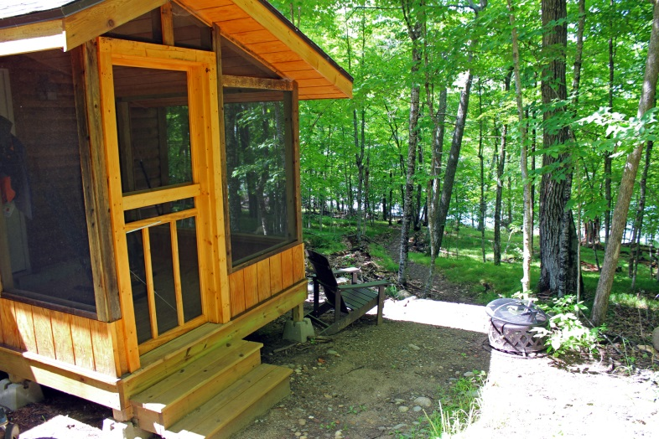
The Hermitage – A cozy cabin intended for year round solo retreats, the Hermitage is tucked away in the forest, isolated from noise and other guests. Inside the cabin is a comfortable bed, sitting area by a large picture window and gas stove, writing table and chair, and adequate light for reading and writing, day or night. A screened porch with rocking chair is surrounded by the variety of trees so typical of Clearwater’s deep forests. We are pleased to provide the Hermitage free of charge to pastors/clergy including CLPs and church professionals.

Chrysalis – Since the mid 1980s, Chrysalis has offered a balanced, faith-building program at Clearwater Forest for women of all Christian traditions. Our vision is to nourish and support the body, mind and spirit in community with other women. There is both a summer and a winter Chrysalis and women of ALL ages are encouraged to come. Our next offering of Chrysalis will be Friday, Feb 21 – Sunday, Feb 23, 2020.
If you have any questions about these or other offerings at Clearwater, please feel free to contact either Rev. Nancy Emerson (nancy68emerson@hotmail.com) or Maggie Sambo (Maggie.sambo@gmail.com). Donations may be sent to the Presbytery or to Clearwater Forest, 16595 Crooked Lake Rd, Deerwood, MN 56444

