How to do a Facebook Live Using Your Smart Phone

- You will need to use your church account. You will need to know who is the administrator of your church account. You cannot do a live post if you are not an administrator or editor. You add administrators under “page roles”
  - 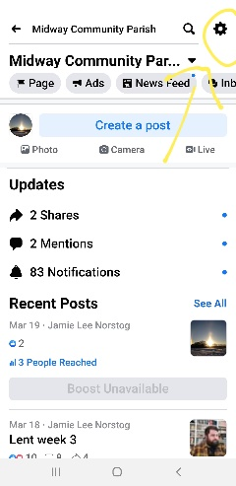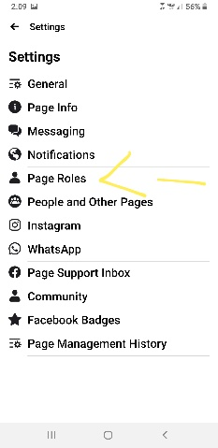
- Go to your church page and create a post. It will look like this.
  - 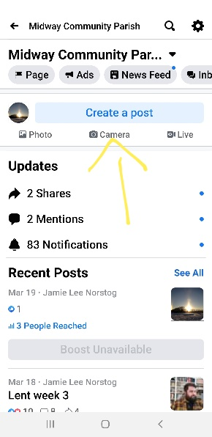
- Next, chose the “go live option”
  - 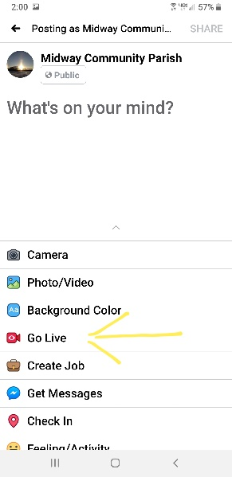
- Now you start the video. Once you started the video, point you camera in the right direction. I recommend setting your phone on a stand of some sort. Otherwise it will shake in your hand and you will lose the video quality. Once you are done recording, click finish and share.
  - 